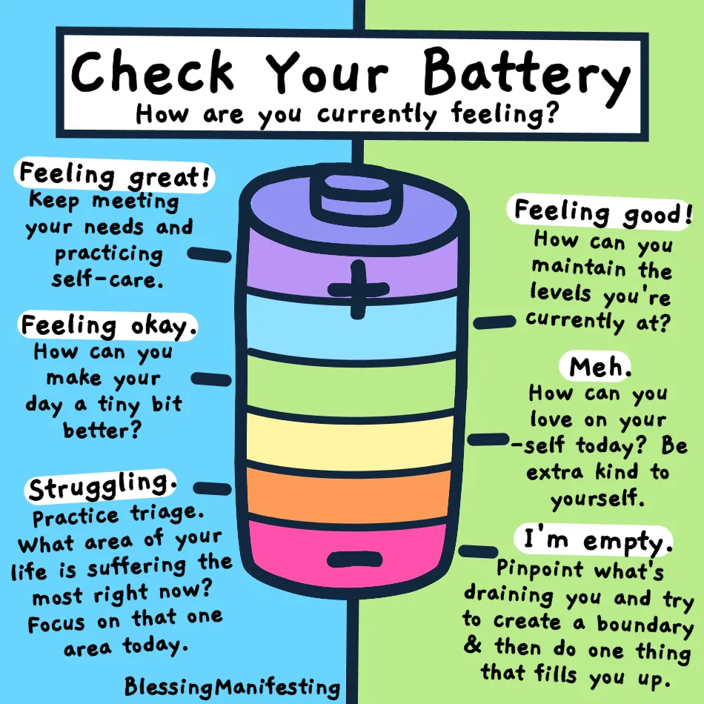
Photo credit to @blessingmanifesting

